Access to Open Weather Map

## How to get accurate API response

1. Do not send requests more than 1 time per 10 minutes from one device/one API key. Normally the weather is not changing so frequently.
2. Use the name of the server as **api.openweathermap.org**. Please never use the IP address of the server.
3. Call API **by city ID** instead of city name, city coordinates or zip code. In this case you get precise respond exactly for your city. **Dublin:** {2964574, Dublin, 53.343990, 6.267190, IE)
4. Free accounts are limited in availability so may not respond.
5. Store requested data.

## Access limitation

If account exceeds the limits, then a notification about limits exceeding is sent. If it repeats again, then the account is blocked for an hour. Therefore, the lock period is increased by one hour until 4 hours block sets. When blocking repeats the fifth time, then the lock period lasts 24 hours. This rule is cycled. Please be careful with the number of API calls you complete.

## How to Request Dynamic Data

import requests

import json

import pprint

url=*'http://api.openweathermap.org/data/2.5/weather?id=2964574&APPID=33e340fbba76a4645e26160abb37f014&units=metric'*

* **From the Above:** url='http://api.openweathermap.org/data/2.5/weather?id=2964574’ - this is the url to request. Then you need to add your API key for Open Weather App.
* 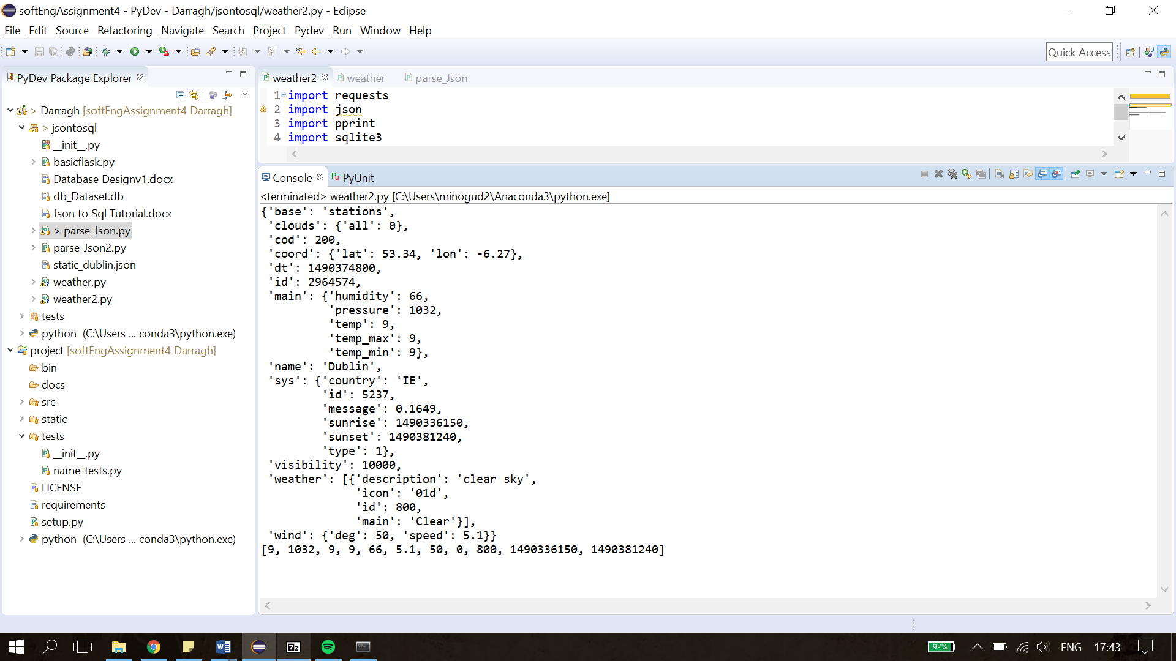**Add URL key:** url='http://api.openweathermap.org/data/2.5/weather?id=2964574&APPID=33e340fbba76a4645e26160abb37f014&units=metric'
* **Metric added at end for specialised units.**

data = requests.get(url).json()

pprint.pprint(data)

* **Pretty Print will print out the dictionary list obtained in vertical format vs horizontal**

**No timestamp included.**

**For more info:** <https://openweathermap.org/current>

1. Could request data every hour from open weather?

{'base': 'stations',

'clouds': {'all': 0},

'cod': 200,

'coord': {'lat': 53.34, 'lon': -6.27},

'dt': 1490374800,

'id': 2964574,

'main': {'humidity': 66,

'pressure': 1032,

'temp': 9,

'temp_max': 9,

'temp_min': 9},

'name': 'Dublin',

'sys': {'country': 'IE',

'id': 5237,

'message': 0.1649,

'sunrise': 1490336150,

'sunset': 1490381240,

'type': 1},

'visibility': 10000,

'weather': [{'description': 'clear sky',

'icon': '01d',

'id': 800,

'main': 'Clear'}],

'wind': {'deg': 50, 'speed': 5.1}}

[9, 1032, 9, 9, 66, 5.1, 50, 0, 800, 1490336150, 1490381240]